**DESIGN DOCUMENT FOR LIBRARY MANAGEMENT SYSTEM**

Design Document

* Technologies used- HTML,CSS,JAVASCRIPT (FRAMEWORK JQUERY),AJAX,PHP.

Reason - These technologies are widely used in the practical world for implementation of a project also I have taken a course in Web Programming Languages this semester in which I am learning these technologies.

1)Book Search-

In the book search module, a librarian can enter multiple keywords like( ISBN TITLE AUTHOR), (Assumption-Keyword entered does not contain any special characters).The search will display a list of books with ISBN, BOOK TITLE, BOOK AUTHOR, AVAILABILITY. Depending on the availability of the book, a librarian can check out the book.

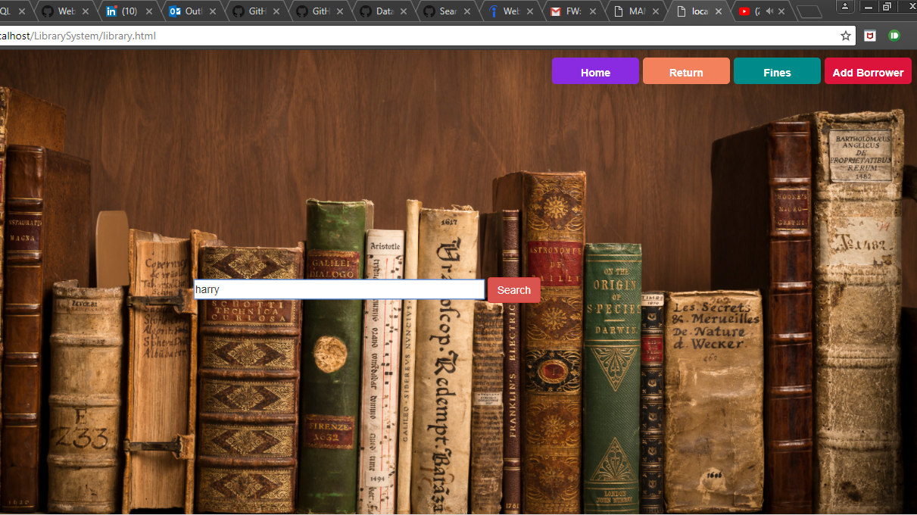

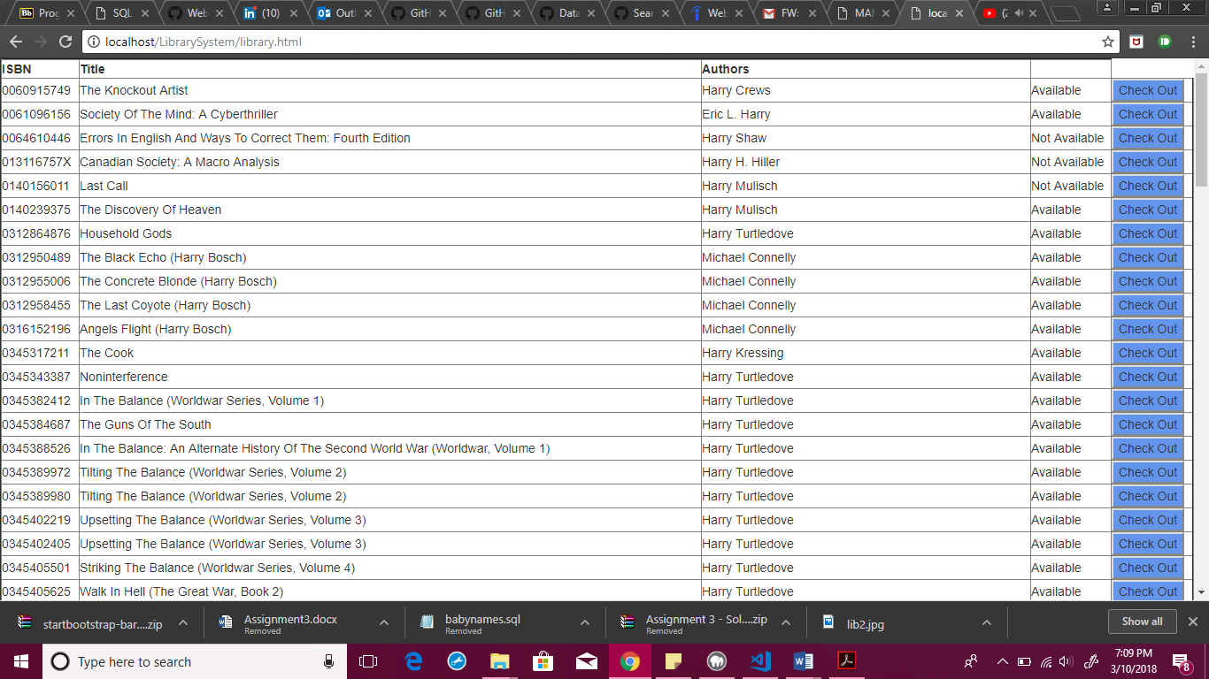

2)Check-Out-

Once found that the book is available the librarian can check out the book by clicking on the available key and the librarian will enter the card id of the user if the user hasn't checked out more than three books he/she is permitted to check out the book and there will be a data entry in the book_loans table or else message will be displayed that the user has reached the limit of checking out three books.

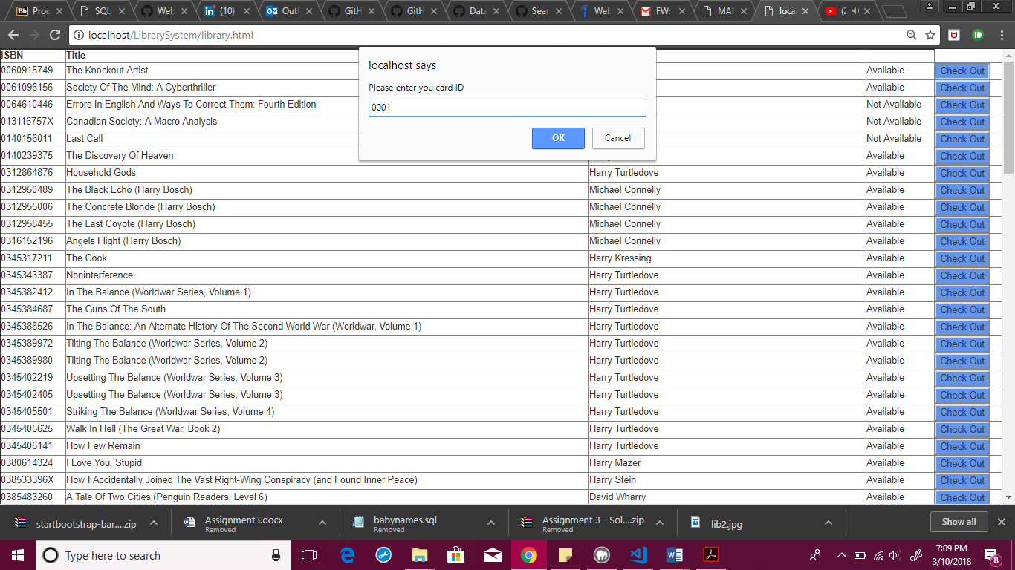

3)Add Borrower-

The librarian can add a borrower. The input fields are specified in the UI. i.e(SSN,Borrower,Address,Phone). If the SSN is same then the entry is rejected or else it is added to the database of the borrower.(Assumption- We were not given SSN but SSN was randomly generated using this website and was added to the table for validation that no two users can be same.website name: <http://mockaroo.com>)

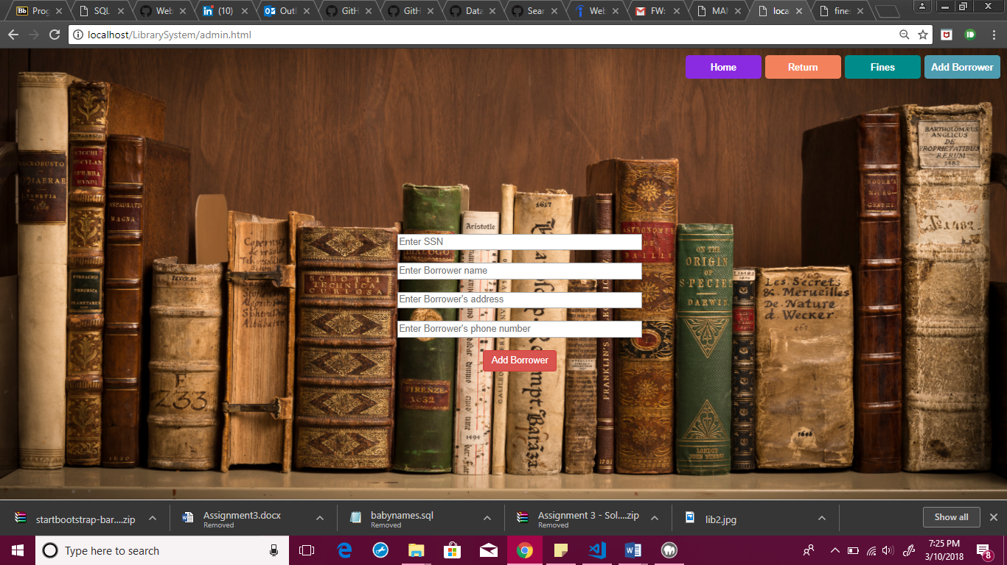

4) Returning a book-

In this module, the librarian can check whether the book is out by keyword Card id or ISBN or Borrower name for returning the book against the card id of the user the librarian the can return by clicking on return button and the date_in will be changed to today's date in the book_loans table.

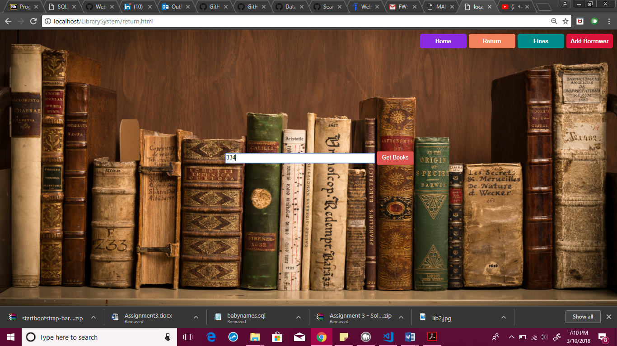

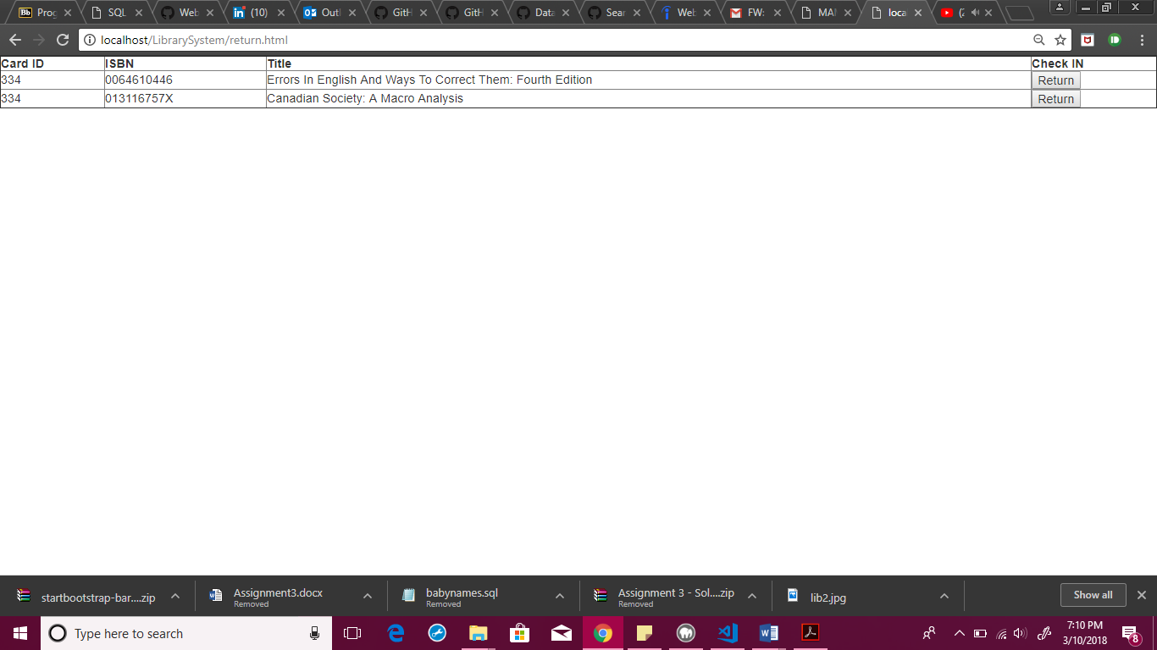

5)Fines-

The fines can be seen against the card id of the user and it can be paid and once the fine is paid the paid column that is a boolean value is changed to 1 and in the next search, it shows that the fine is paid.When the librarian clicks on the update button the fines are recalculated for the books that are out according to the current date and stored in the database.

